|  |  |  |
| --- | --- | --- |
|  | **Rochester Institute of Technology**  **Golisano College of Computing and Information Sciences**  **School of Interactive Games and Media**  **2145 Golisano Hall – (585) 475-7680** |  |

**Data Structures & Algorithms for Games & Simulation II**

**IGME 309**

**A04 - Camera**

For this assignment, there is starter code provided in the repository, you are not required to use said starting code or the framework for it, you can use your own solution, but it will be your responsibility to translate the provided startup code on your own.

In the class repository, I’ve included a solution under the _Binary folder. Please take a look at that and at the video instructions before continuing reading this document:

The starter code will give you this out of the box:

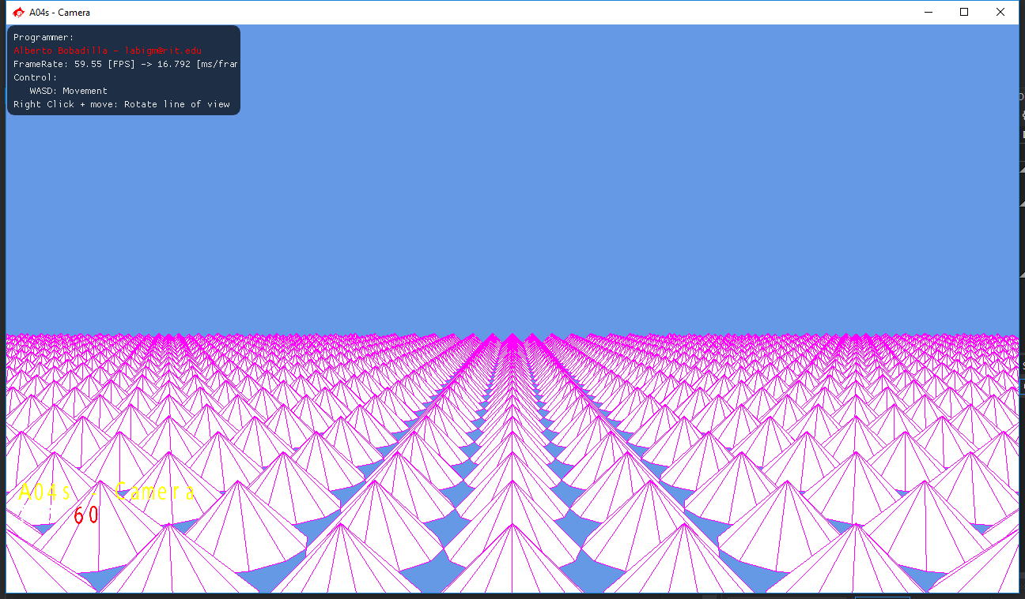

In this scene we are rendering 2500 triangles, but you cannot see them all as you are right at the center of the scene.

There are no controls for this scene, the BasicX/Simplex keyboard has been disconnected.

What you need to do for this assignment is to calculate the movement of the camera, 30% of the grade will come from movements like moving forward, backward, and sideways without turning your view.

20% will come from turning your camera by holding the right mouse button and dragging it, only two rotations are necessary, horizontal and vertical.

50% of your grade will actually move forward, backwards and sideways according to your line of view, not in world coordinates but in the space of the camera. What I mean with this is, imagine you press W for a while, that should move you closer to the edge of the world, if you leave the cones behind of you and turn 90 degrees horizontally you would have the cones right in front of you. If you press W that should move you closer to the cones again, if it takes you away from them you are moving in world space not according to the camera view.

Your grade will be 100% if your solution behaves like the one provided and based on the previous description. Deductions will happen as follows:

-20% If you hardcode things in the camera.

-20% If you did not comment your code.

-30% your camera has Gimbal Lock

+???% There is no specified extra credit for this assignment, but I’m willing to give you extra credit if you surprise me (in a good way)

Hints:

* Try moving the camera forward backwards left and right first that is the easy part, then rotate your view and then move in that view.
* There is a complication if you look perfectly up, that will make your up vector align with your view, I will not deduct points for this but take in consideration that there are multiple solutions specially if you are avoiding the Gimbal Lock.
* There is no need to move when you are in the orthographic projection, the view could be completely static as in my provided solution.

***Submit to the dropbox labeled A04 – Camera***

As usual the required submission asks only for the project folder, not the whole solution, it should be no larger than 200kb if you are using the starter code (and you remove this document from that folder). If you are using your own framework/engine please submit the whole solution. In both cases in the comment section of your submission you need to specify the address of your repository.